St John’s Lutheran School, Jindera

We’re almost halfway through the year and so far, it’s packed a punch!

Our leadership team are placing a lot of focus on collaboration with Riverina School, with the creation of InspirED. Our students are immersing themselves in our academic curriculum and we are focussing on helping to develop our students’ well-being through our revised ‘Restorative Practices’ program. We’ve also had a lot of fun with all three major sporting events and our senior primary students making the most of their camps in term 2!

Message from our School Leadership
Throughout the past five years, one area our leadership team have intentionally invested energy and focus on, is building staff collaboration within our school team. This intent is also true for the building of relationships with our colleagues from our four Riverina schools in Henty, Walla and Wagga.

The desire for our Riverina Lutheran schools to collaborate is wholeheartedly supported by our school Principals, board members and staff. This commitment to Lutheran Riverina Education has resulted in the creation of InspirED.

What is InspirED?

- A seamless P-12 Lutheran education in the Riverina: InspirED is a community of four Riverina-based Lutheran schools providing a seamless educational experience from Pre-school to Year 12. InspirED families can expect a consistent approach underpinned by Lutheran values and a shared understanding of purpose and educational excellence.
- Caring, committed and child-centred: At InspirED schools, we consider the whole person and appreciate each student’s individuality, circumstance, contributions and challenges. We define educational excellence in terms of the support we provide the individual student to be at their best in terms of wellbeing, belonging and community connectedness, and exploring and reaching their academic and personal potential, whatever that may be.
- A safe space for students to grow: We provide a comfortable, positive and safe space for our students to learn and grow as people and lifelong learners in an environment that values diversity, acceptance and inclusivity. We believe that building a strong sense of community makes our schools places of belonging, which benefits everyone.
- Innovative learning and teaching for life beyond the classroom: At InspirED schools, our students learn to learn. Our well-qualified staff value lifelong learning and invest in their own development as well as the development of their students. Our innovative, engaging and rich curriculum challenges students while equipping them to make a positive and meaningful contribution to society. While we value academic excellence, our focus is bigger than the classroom. For us, it’s about expanding minds and possibilities.
- Stronger together: InspirED schools benefit from interdependence. We are a resource to each other. As a community, we are stronger than the sum of our individual parts. Just as our schools are stronger together, we instil in our students and families the understanding that they are part of something larger than themselves.

On our staff Professional Development Day at the start of Term 2, we travelled to learn with our colleagues from Wagga Lutheran School and St Paul’s Lutheran School, Henty. It was a fantastic day working with Sam Kourakis, from AIS NSW, where she led all staff through restorative practices and how we support positive student well-being.

The final session of the day saw Anna-Marie Bothe from our school working with Henty and Wagga staff on project-based learning, while Dylan Evans from Wagga continued working on restorative circles with Jindera staff.
It was a fantastic day of collaboration and an example of our Riverina schools working together for the benefit of our students. It reinforces the power of InspirED and the intention of collaboration between staff in Wagga, Walla, Jindera and Henty.
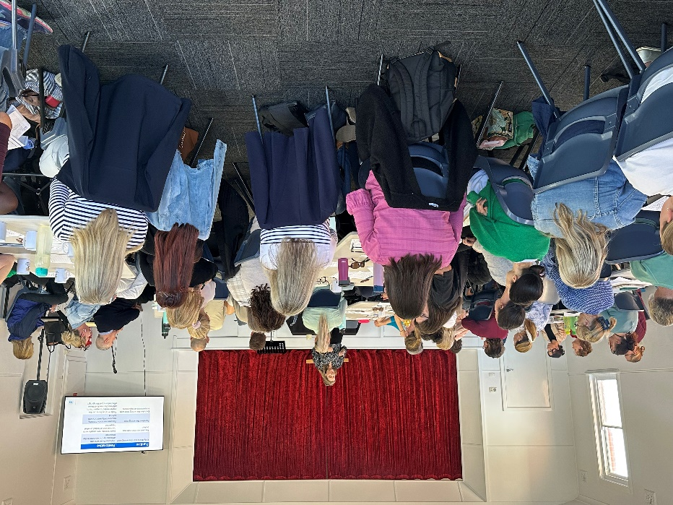
We’re excited about the potential of InspirED and increasing positive school experiences for our learners. Our goal is to INSPIRE students for life!

Yours in Christian service,
St John’s Leadership Team

Restorative Practices
St John’s is a Restorative Practices school. Our staff have recently participated in refresher professional development and our whole school will focus on Restorative Practices this term. As a Christian school, these practices help us put God’s love into practice to build meaningful connections with each other.
What are Restorative Practices?
Restorative Practices acknowledge that harm is caused when our school expectations for behaviour and respect are not followed, creating a need for healing and restored relationships. They go hand-in-hand with our school positive behaviour approach, including teaching students that there are consequences for actions.
Restorative Conversations
When harm has been caused, our leaders, teachers and learning coaches use the following WARM conversation format:
What happened?
How were others Affected? (E.g. feelings hurt, being disrespected)
How can we Restore relationships and Repair hurt?
How can we Move forward from here and what will happen if it occurs again?
These conversations can happen incidentally in class or the playground or can be conducted formally by staff or members of the Leadership Team, depending on circumstances.
Restorative Circles
Each class has been using this highly valuable and effective strategy in their classroom. The class sits in a circle and discusses a topic relating to social and emotional learning provided by the teacher or a student. Rules for showing respect and taking turns ensure everyone can speak if they want to and different perspectives are respected. Research has shown that this strategy effectively improves student behaviour and relationships in schools.

Sporting Carnivals

Over term 1 and 2, the students showed off their best sporting abilities and sportsmanship with our swimming carnival, cross country and athletics carnival and we have superb weather for every event!
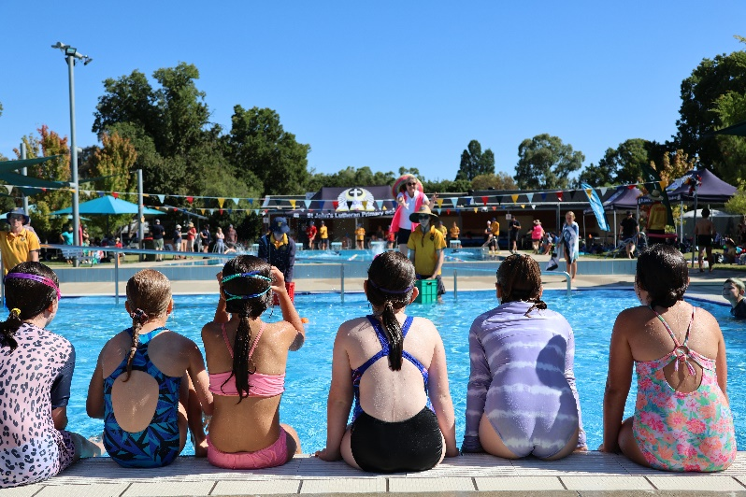
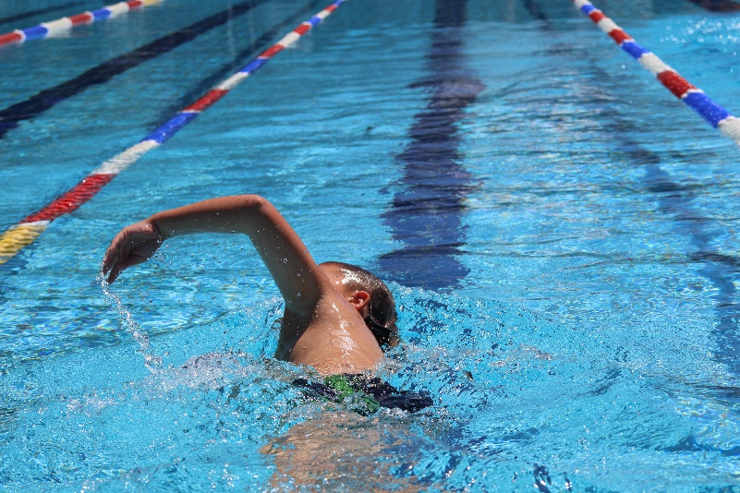

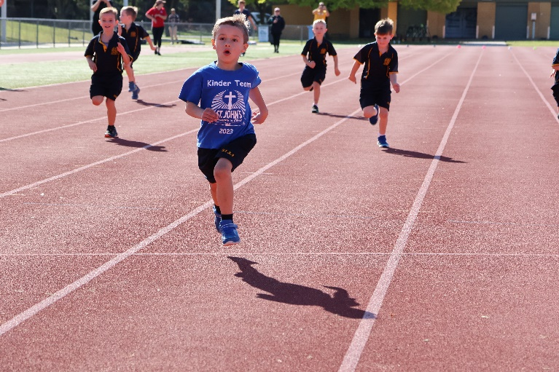
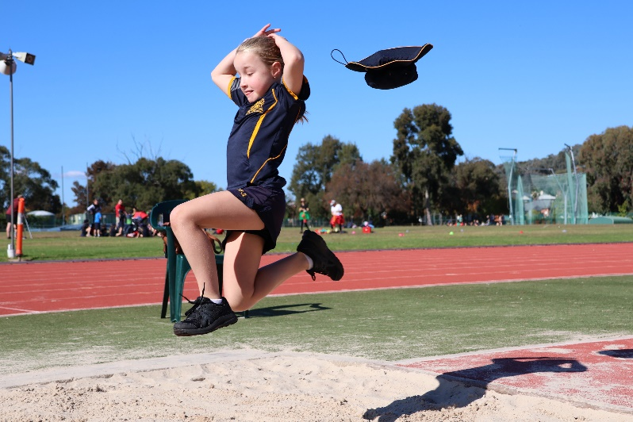
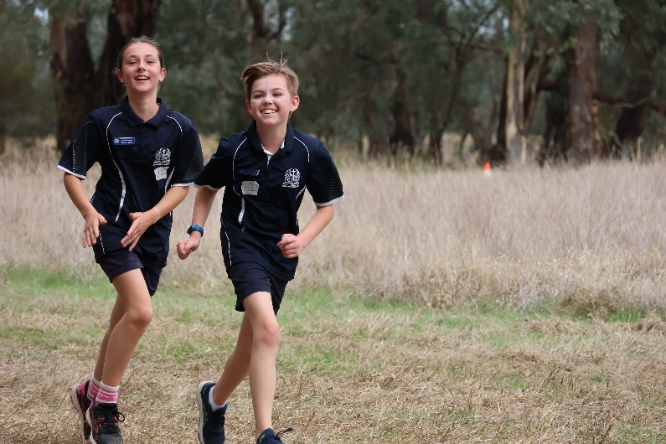
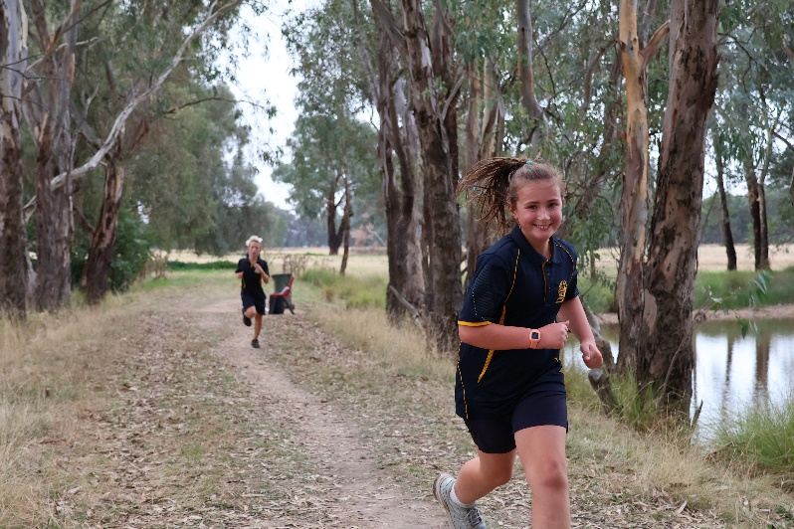

Year 3/4 Camp to Echuca

The Year 3/4 camp to Echuca was an amazing success. It was wonderful to see students outside the school environment. Every student displayed their best qualities making our school proud. Students were complimented on their engagement and behaviour during their interactions with the guides and public. The camp provided opportunities for each child (and adult) to step out of their comfort zones and support each other. From swinging on ropes, following instructions, to organising our belongings.

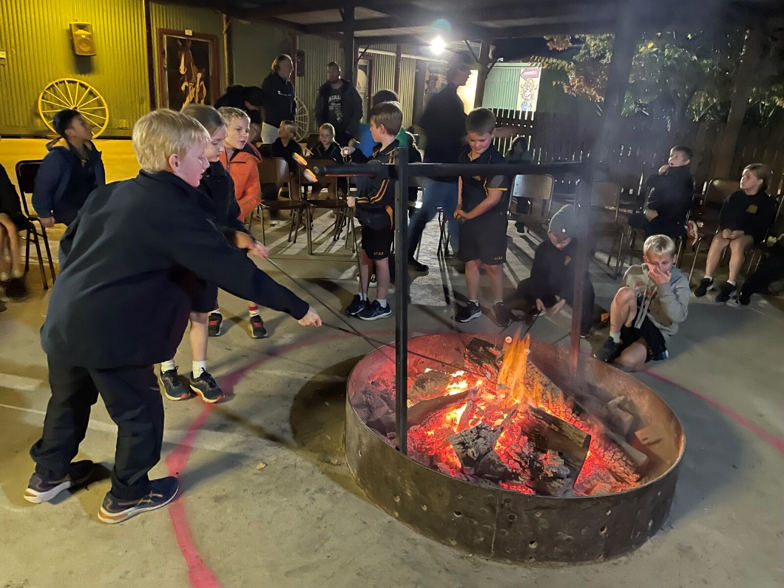

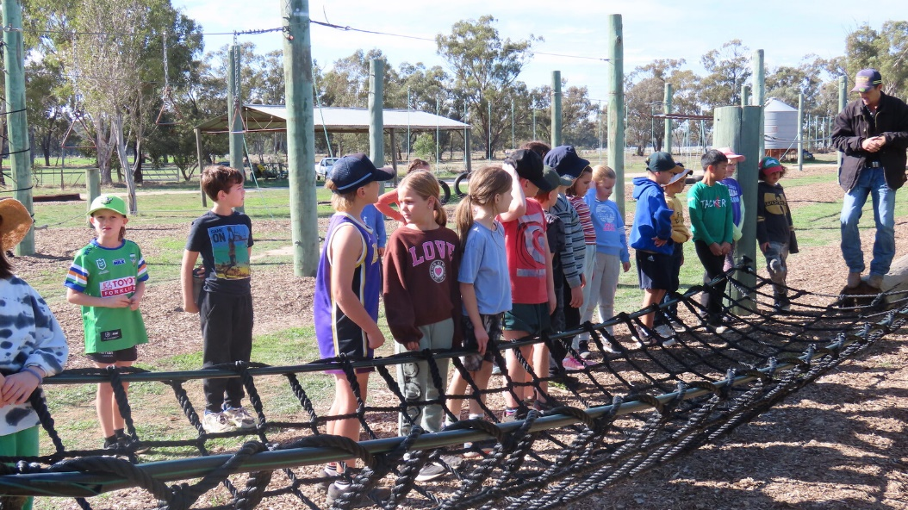

Year 5/6 Camp to Ballarat

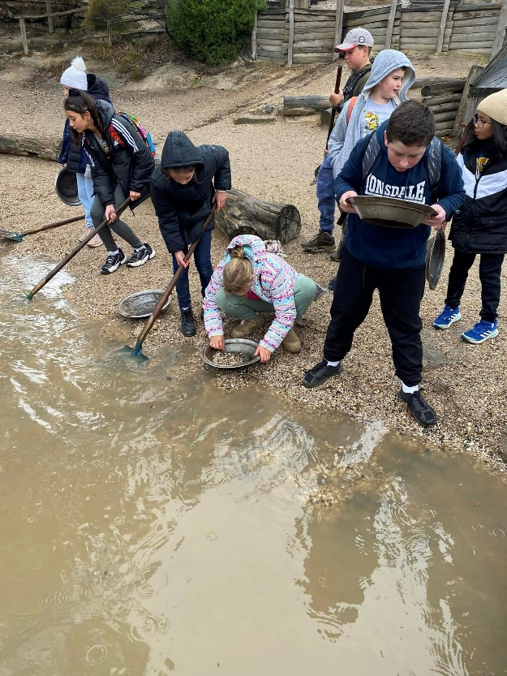
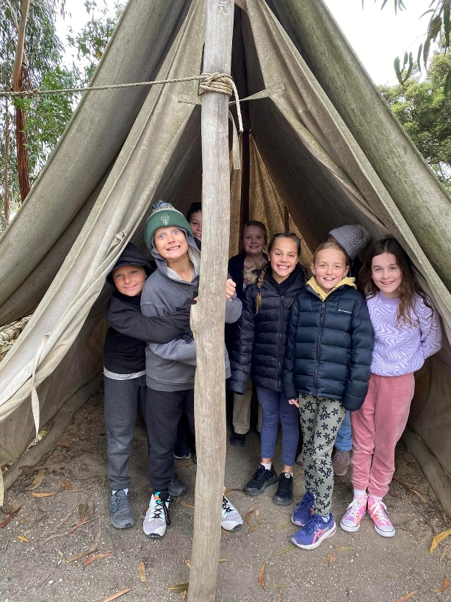
The year 5/6 students embarked on their journey to Ballarat! The camp was historically informative, students engaged in curious discussions with Sovereign Hill staff and although battling the wet weather, they made the most of their new experiences, learning and deepening friendships!

