Kitchen Hand
Position Description

Position Title | Kitchen Hand | Reports To | Catering Services Manager
Location | Warrambui | Requirements | - Drivers License – Class C  - NSW Working with Children Check
Last Updated | November 2022
ROLE PURPOSE
To assist in the preparation and cooking of food, with kitchen cleaning duties and with other aspects of the catering operations at Warrambui to provide quality food and service to guests.
NATURE AND SCOPE
Warrambui is a Christian Retreat and Conference Centre located 40 minutes north of Canberra’s centre on 120 ha of natural bushland. We are owned and operated by the Lutheran Church of Australia NSW & ACT District, and exist to provide a centre for Christian camping, conferencing and retreat.
Our mission at Warrambui is to serve people by living Jesus and we provide fully-catered accommodation and programs to our guests. Groups come to Warrambui from all around Australia and include primary and secondary schools, and church, youth and community groups.
Warrambui has 216 beds spread across two venues, with multiple meeting spaces, and conference and outdoor facilities.
All employees and volunteers of Warrambui are required to carry out their responsibilities and duties in accordance with the values and ethos of the Lutheran Church of Australia, being governed by God’s love and forgiveness. This includes valuing and respecting all people, acting with integrity and accountability, and being committed to growth both individually and as a team.
This position requires a Christian or a person who is accepting of the Christian faith.
As part of the Warrambui community, this position requires a flexible, open, team player, and someone with a servant heart who is willing to go the extra mile for clients and fellow Warrambui team members.
This role plays a key part in Warrambui’s mission to “Serve people by living Jesus” as they will often interact with guests and be the face of Warrambui to them.
KEY ROLE RESPONSIBILITIES
- To assist in preparing and cooking meals for Warrambui’s guests (breakfasts, lunches, packed lunches, dinners, morning/afternoon teas and suppers).
- To perform basic cooking duties such as cooking breakfasts and baking.
- To perform kitchen cleaning duties including the cleaning of dishes, appliances and surfaces.
- To be responsible to the Catering Services Manager to help ensure that the food needs of guests are met.
- To adhere to Warrambui’s food safety plan and to required food safety standards.
- To work collectively and cooperatively together with the other Warrambui staff and the Interns.
- To contribute to the Warrambui team including team meetings, team building activities, planning days etc.
- Other duties as required.
SELECTION CRITERIA
- Qualifications and/or experience in assisting with the preparation and service of food.
- Qualifications and/or experience in food safety.
- A good work ethic, and strong time management, organisational, and teamwork skills.
REPORTING STRUCTURE
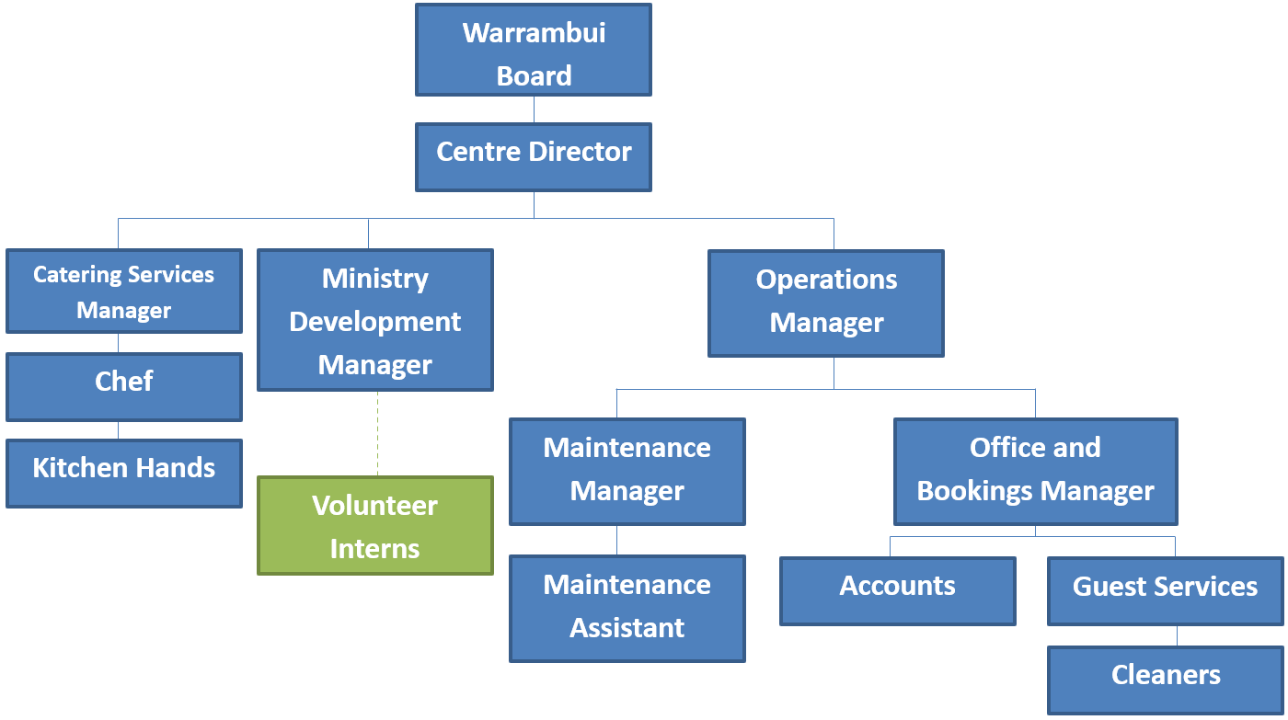
SALARY AND CONDITIONS
The Kitchen Hand will be employed in accordance with the Hospitality Industry (General) Award 2020 with salary and conditions negotiated based on the person’s qualifications and experience.

SAFEGUARDING CHILDREN AND YOUNG PEOPLE
Warrambui takes child protection seriously, and as an employee of Warrambui, the Kitchen Hand is required to meet the behaviour standards outlined in our ‘Safeguarding Code of Conduct’. A copy of the code will be provided as part of induction and can also be accessed on the All Staff/Policies and Procedures drive.
Therefore, as a part of their duties and responsibilities, the Kitchen Hand is also required to:
- provide a welcoming and safe environment for, children, young people and vulnerable persons
- promote the safety and wellbeing of children, young people and vulnerable persons to whom we provide services
- ensure that your interactions with children, young people and vulnerable persons are positive and safe
- provide adequate care and supervision of children, young people and vulnerable persons in your charge
- act as a positive role model for children and young people
- report any suspicions, concerns, allegations or disclosures of alleged abuse to the authorities and to management (further information can be found here:
http://www.legislation.nsw.gov.au/#/view/act/1998/157/chap3/part2/sec27)
- maintain valid ‘working with children’ documentation
- report to management any criminal charges or convictions you receive during the course of your employment that may indicate a possible risk to children, young people and vulnerable persons.

Conditions of Employment
Warrambui undertakes several screening processes to ensure the appropriate protection of children in its care. This includes reference, identity, qualification, professional registration and child safety checks. Failure to provide this information or detection of having provided false information may lead to immediate dismissal.

Acknowledgement
I acknowledge that I have read and understood the requirements of this position.
Name:
Signature:
Date:

